# To-Do List

1. Save the overview of correct preds/total preds in global variable to call separately after running the code (both, for the fine-tuning section and the hyperparameter tuning section) 🡪 better saving in csv file so it does not get overwritten
2. Update the model without custom head by using AutoModelForSequenceClassification 🡪 implemented! check if changes work

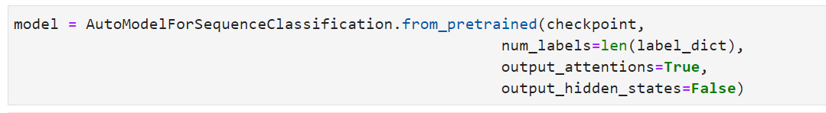

* With that, a head is automatically instanciated for classification

1. Replace BertForPretaining method with AutoModelForSequenceClassification for the models with custom head 🡪 implemented! check if changes work
2. Include code for class weights that can be uncommented if not needed (like it was included in the previous project) 🡪 for model1 is will be done after meeting
3. Explain if in the following part of the code, the part with the custom_head = True also needs to be adapted to False if we use in the other cell custom_head = False:

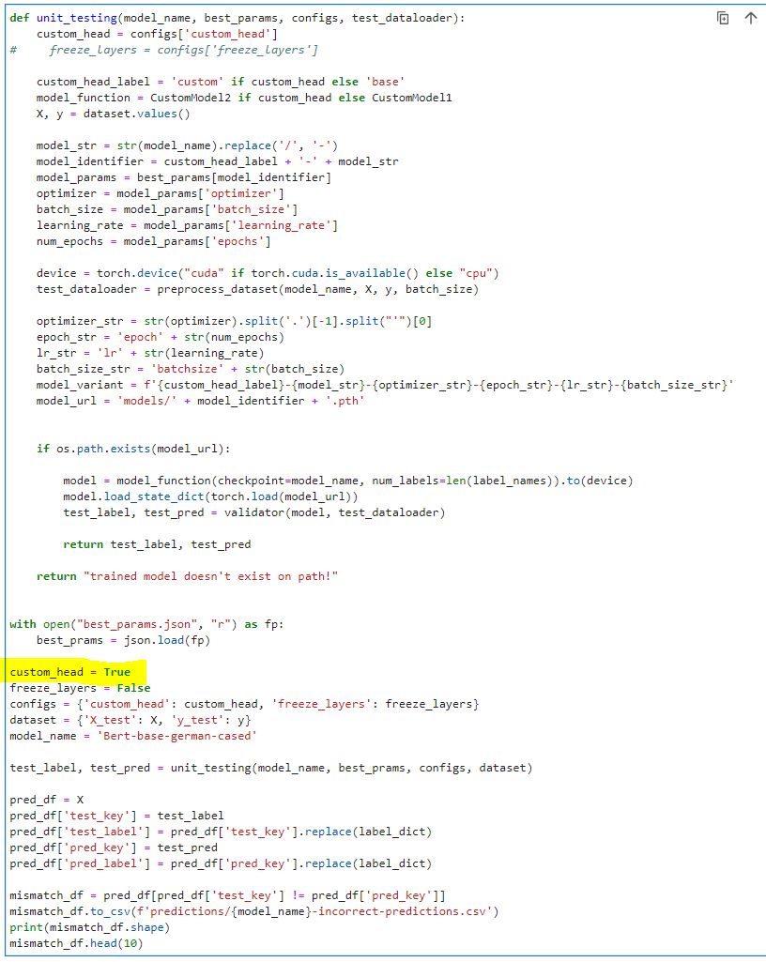

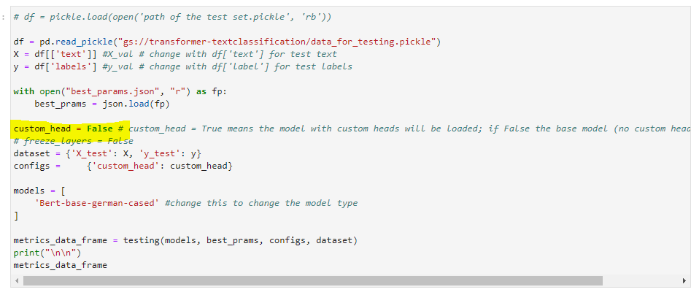

In general: please clearly mark all parts of the code where manual configuration is necessary! Commenting the code or providing headlines helps understanding the code much better.

1. Explain what unit_testing is different from the other testing code. 🡪 could be merged, but can also stay separate. It is two separate cells because of how the code was structured before
2. Please provide in a separate notebook the pipeline without fine-tuning. So all the same (models with custom head and models without custom head) but only the hyperparameter/training the model part and the testing part should be included (layers not freezed). It is basically what you have provided for the first project pipeline-wise. That way we can compare performance of separately training the classifier on the data first versus training the whole model directly. 🡪 Implemented! check if it works (model1)
3. Implement attention weights in a similar way like in the code file we will send you.